PROJECT DOCUMENTATION
Content Gen - Generate high-quality blog
content using AI

Team ID: SWTID-2026-9012
Team Size: 5
Team Leader : ANITHA E
Email : teekarani033@gmail.com
Team member : AAISHA MUSTARI A
Email : aaaishamustaria@gmail.com
Team member : AFRIN NAFIA P M
Email : afrinnafia2@gmail.com
Team member : BHAVADHARSHINI P
Email : dharshini04022007@gmail.com
Team member : BHAVANA KUMARI
Email : bhavanachouhan621@gmail.com

INTRODUCTION
BlogNest is a backend-based AI-powered blogging system developed using Node.js, Express.js, MongoDB, and Mongoose.
The system allows users to securely register, login, create and manage blogs, retrieve blog content, and generate blogs using Google Gemini AI.
It also provides an AI-based content summarization feature to generate concise summaries of given content.
JWT is used for authentication, bcrypt is used for password encryption, and Google Gemini AI is integrated for intelligent content generation and summarization.

Project Description
The AI BlogNest API is a secure, intelligent, and scalable REST API platform designed to simplify blog creation, content management, AI-assisted writing, and content discovery. The system provides a centralized backend environment where users can create, manage, update, organize, and retrieve blog content through structured API endpoints.Built using Node.js and Express.js, the application uses MongoDB with Mongoose ODM for efficient data storage, schema validation, and database operations. The backend follows a modular architecture that separates routing, controllers, services, middleware, and database models to improve maintainability and scalability.
Security is an important part of the system. JWT-based authentication, password hashing using bcrypt, role-based authorization, request validation, input sanitization, centralized error handling, and protected API routes are used to maintain secure backend operations.The AI BlogNest API combines traditional blog management with AI-assisted content generation to provide a smarter and more efficient content management experience.

Scenario-Based Case Study
Background
Priya is a content creator who manages several blogs related to technology, education, lifestyle, and other topics. As the number of articles increases, managing drafts, categories, tags, and published posts becomes difficult.She also spends considerable time preparing the initial content for every article. Searching for existing posts and maintaining organized content becomes challenging when the blog collection grows.

Problem
➢ Difficulty managing multiple blog posts and drafts.
➢ Time-consuming manual blog content preparation.
➢ Difficulty organizing blogs using categories and tags.
➢ Limited automation for generating initial blog content.
➢ Difficulty searching and retrieving required articles.

Solution
The AI BlogNest API provides a centralized and secure backend for managing the complete blog workflow. It provides RESTful endpoints for user authentication, blog management, categories, search, and AI services.The AI service connects with Google Gemini to generate structured blog content from a given topic. It can also summarize existing content into a shorter form.
JWT authentication protects private endpoints, while role-based authorization controls operations according to the user's permissions. MongoDB stores the application data and Mongoose provides schema validation and database interaction.

Usage
- Admin Usage: Manages users, blog records, categories, permissions, and system operations.
- Content Creator Usage: Creates and updates blogs, manages personal content, and uses AI-assisted blog generation.
- Authenticated User Usage: Views available blogs, searches content, and accesses permitted services.
- Public Reader Usage: Reads published blogs and searches publicly available content without accessing protected API operations.

Outcome
By moving blog management into a centralized backend, repetitive content operations are reduced and the overall workflow becomes more organized. AI assistance reduces the manual effort involved in preparing initial blog drafts and summaries. Database validation maintains structured records, while authentication and authorization protect private resources.

1. Software Requirements
- Operating System: Windows 10/11, macOS, or Linux for cross-platform development.
- Node.js: Runtime environment used to execute server-side JavaScript.
- npm: Package manager used to install and manage backend dependencies.
- Express.js: Lightweight framework used to create RESTful API endpoints.
- MongoDB: NoSQL database used to store users, blogs, categories, and related data.
- Mongoose ODM: Used for schema definition, validation, and MongoDB communication.
- Postman / Thunder Client: Used for testing API requests and responses.
- Visual Studio Code: Development environment for writing and managing project files.
- Google Gemini AI: Used for AI-powered blog generation and content assistance
2. Hardware Requirements
- Processor: Intel Core i5 8th Generation or above / AMD Ryzen 5 or equivalent.
- RAM: 8 GB minimum; 16 GB recommended for running MongoDB and development tools together.
- Storage: At least 1 GB of available workspace for project files and dependencies.
- Internet Connection: Required for package installation and communication with the external AI service.
Epic:-1 Project Architecture

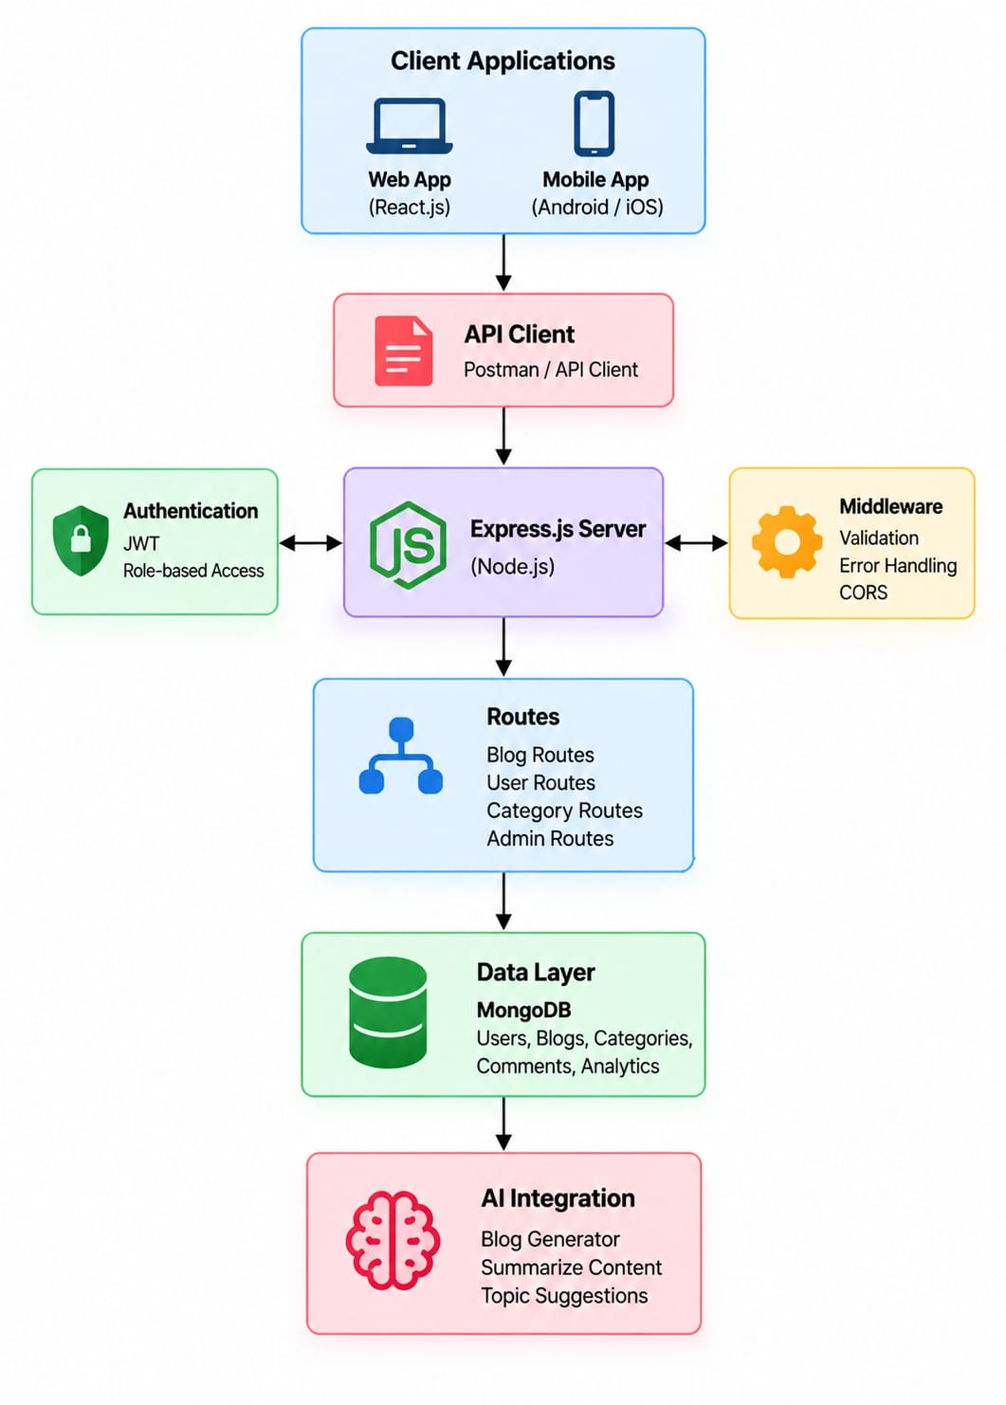
BACKEND ARCHITECTURE DIAGRAM

BACKEND ARCHITECTURE DIAGRAM
The architecture separates authentication, business logic, database operations, and AI processing into independent components. This improves maintainability and makes the backend easier to extend.

Components Definition
- API Gateway: Handles incoming HTTP requests and directs them to the appropriate API routes. It manages request routing, JSON data handling, CORS configuration, and response formatting, providing a common entry point for communication between clients and the backend system.
- Middleware Layer: Performs important request-processing tasks such as JWT token verification, user authorization, input validation, and data sanitization. It ensures that only valid and properly authenticated requests are allowed to access protected backend resources.
- Controller Layer: Receives requests from the API routes and coordinates the required application operations. It processes input data, communicates with the service layer, and prepares suitable JSON responses to be returned to the client.
- Services Layer: Contains the main business logic of the application. It manages operations related to blogs, users, categories, search functionality, and AI-based processing while keeping the application logic separate from the controllers.
- Database Layer: Uses Mongoose ODM to communicate with MongoDB and manage structured application data. It handles schema definitions, data validation, database queries, and CRUD operations for users, blogs, categories, and other stored information.

Entity-Relationship Diagram Description
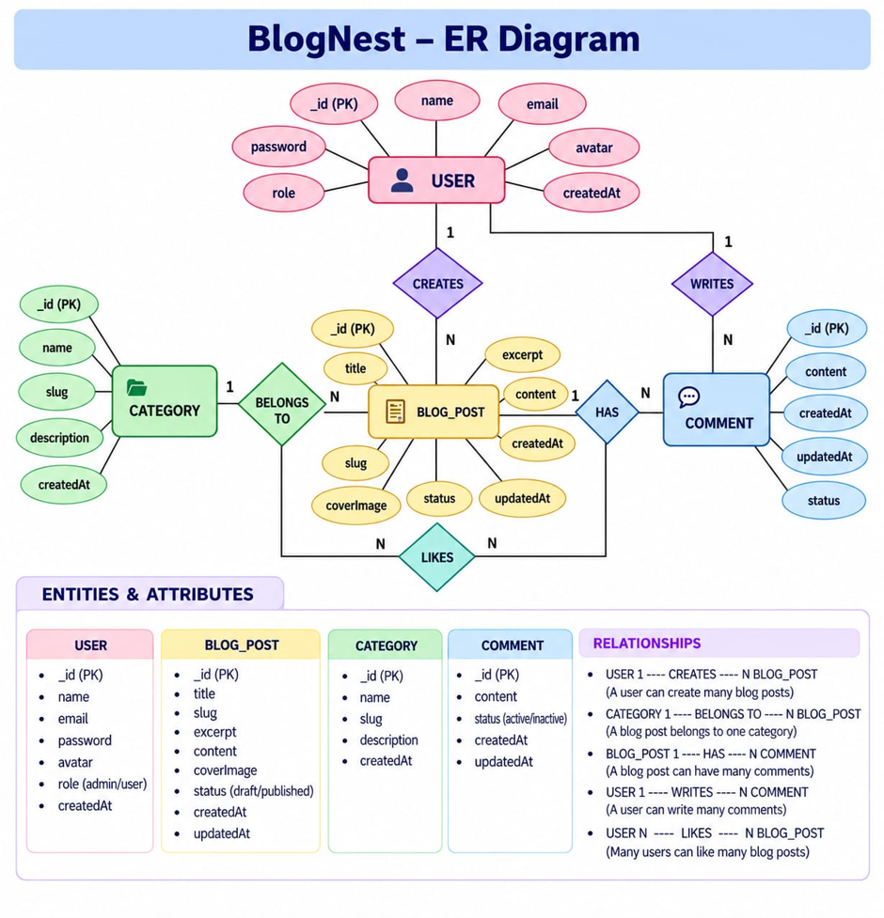
The AI BlogNest API uses connected entities such as User, Blog, Category, and AI Generation to organize application data.These relationships help manage users, blog posts, categories, and AI-generated content efficiently.
1.User Entity

- _id ( Primary Key – ObjectId)
- name ( String, Required)
- email (String, Required, Unique)
- password ( String, Hashed, Required)
- role (String, Default: "reader")

2. Post Entity

- _id (IPrimary Key – ObjectId)
- userID ( Foreign Key referencing User Collection)
- name ( String, Required – represents the post title)
- photo (Object/String pathway link)
- message (String – main content body)
- likes (Number, Default: 0)
- timestamps (True)

Key Structural Mappings
- User to Post (One-to-Many): An author can submit multiple blog documents.
- User to Comment (One-to-Many): A user or reader can add multiple comments to different posts. One author can create and submit multiple blog posts.
- Post to Comment (One-to-Many): Each blog post can contain multiple individual comments.

Key Features
- Role-Based Route Guarding: Token-based authorization prevents users without permission from changing protected settings.
- CRUD Blog Execution Engine: Provides complete management of blog content, status information, and assigned assets.
- Categorization System: Tags and categories support easier filtering and searching of blog content.
- Comment Moderation Logic: Provides protected controls for managing comment states such as approved, pending, and spam.
- Sanitization Safeguards: Cleans input parameters to help prevent XSS attacks and NoSQL injection attempts.
- AI-Driven Blog Generation Pipeline: Uses external Large Language Model (LLM) services and context-based prompts to create structured blog posts from given topics.
- Intelligent Content Summarization Engine: Processes large article content and produces short summaries and useful metadata automatically.
Roles and Responsibilities
- Admin: Has complete system-level control. Can manage user registrations, assign roles, remove harmful comments, and review system logs.
- Editor: Handles editorial activities by reviewing draft posts, approving content for publication, and managing category-related tasks.
- Author: Has restricted account access. Can create posts only within the permissions linked to their assigned account.
- Reader: Has consumer-level access. Can read published content and post comments using an authenticated user identity.

User Flow

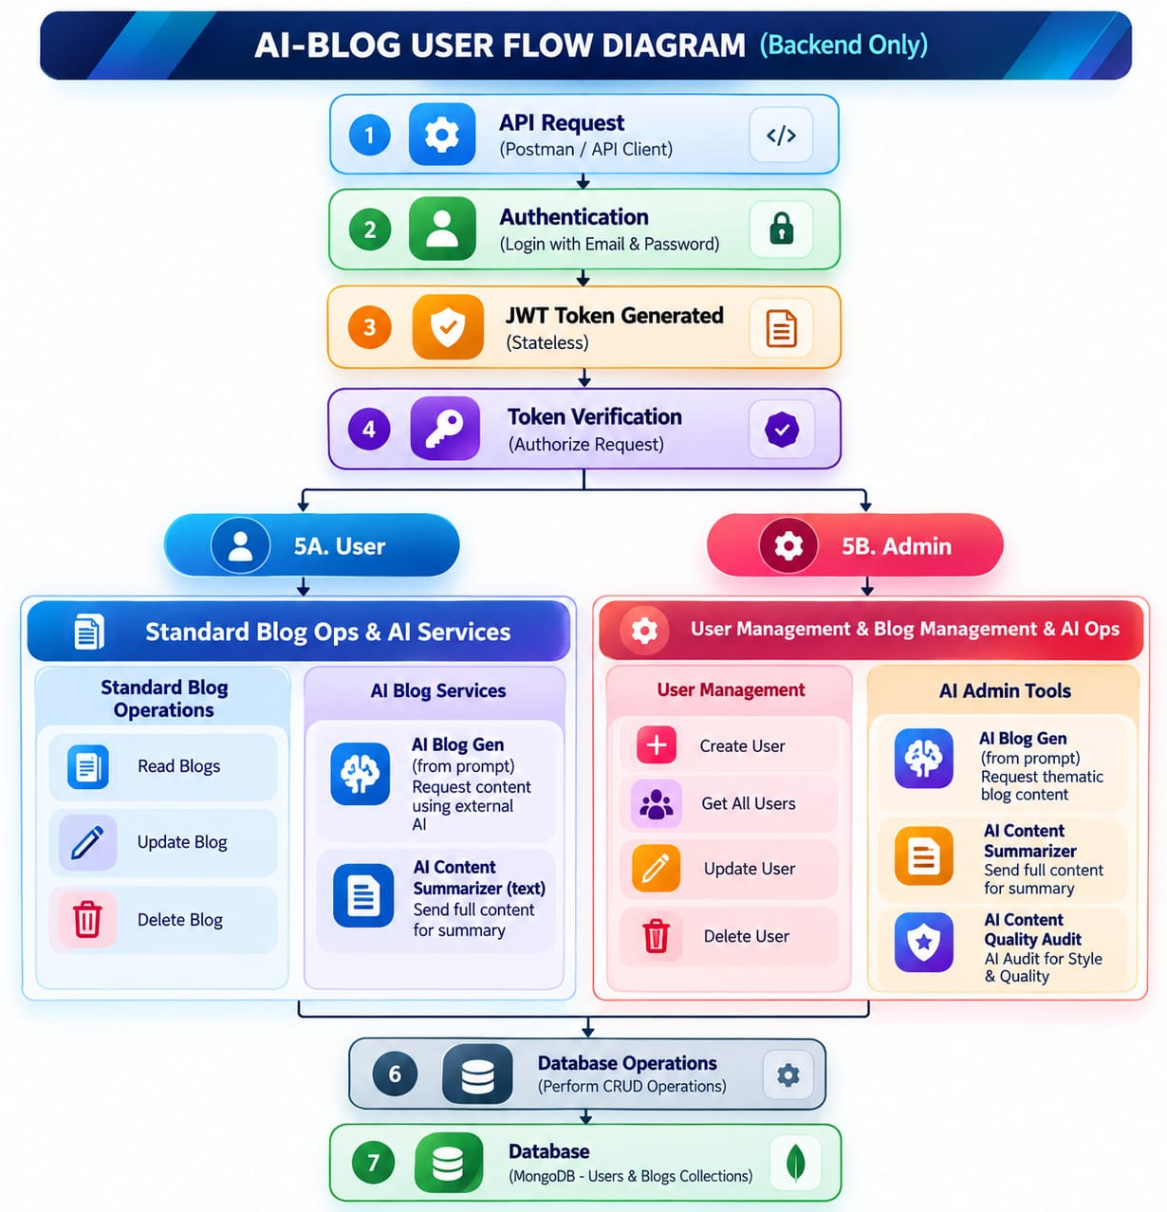

MVC Architecture Pattern
The system organizes its backend configuration using the Model-View-Controller (MVC) design pattern, keeping the major components clearly separated.

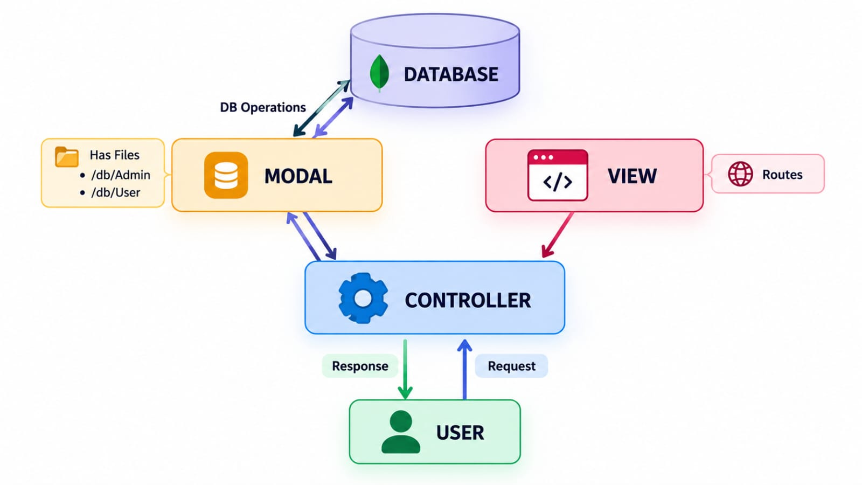

Model Layer (Data Management)
The Model Layer is responsible for handling the application's data and business logic. It defines the database structure using models and schemas, manages data storage and retrieval, and ensures that all data is validated before being saved. This layer communicates directly with the database and maintains data consistency.

Controller Layer (Request Processing)
The Controller Layer manages incoming client requests and controls the flow of the application. It receives user requests, processes the required operations, communicates with the Model Layer to access or modify data, and returns the appropriate response. It helps separate the application's logic from data management.

View Layer (User Response Interface)
The View Layer is responsible for presenting information to users. It displays the output received from the Controller Layer in a clear and organized format. In web applications, it generates web pages or templates, while in REST APIs it usually returns responses in JSON format. This layer focuses only on how the information is presented to the client.

Epic2: Project Setup and Configuration
1. Created a new folder with your <project name>.
2. folder create one new folders.
3. Naming another one as Server.
4. opened that folder in VS Code.


Server setup (npm init)
- Open Server folder in terminal of VScode
  - npm init-y
- Create files:
  - server.js
- Create folders:
  - models
  - controllers
  - routes
Epic 3: Backend Development
Server.js

app.js

Epic4: Database Configuration

- DB Connection



1. Configuration of MongoDB
- Mongoose
- database connection.
- Schemas & Models.

Mongoose Schema Definitions

Identity Resource Document Schema (schemas/userModel.js)
The Identity Resource Document Schema defines the structure and validation rules for user-related data stored in the MongoDB database.
It ensures that incoming user data follows the required field criteria before it is saved to the database. The schema specifies the required fields, data types, and validation conditions for each user attribute.
This schema helps maintain data consistency and prevents invalid or incomplete user information from being stored in the database.
Epic 5: Project Executions
User Registration :
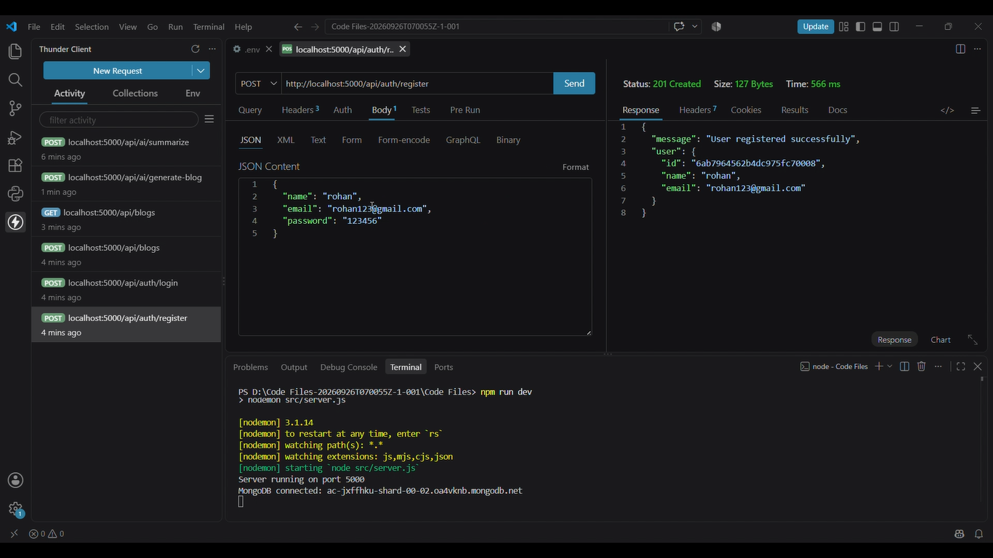

User Login
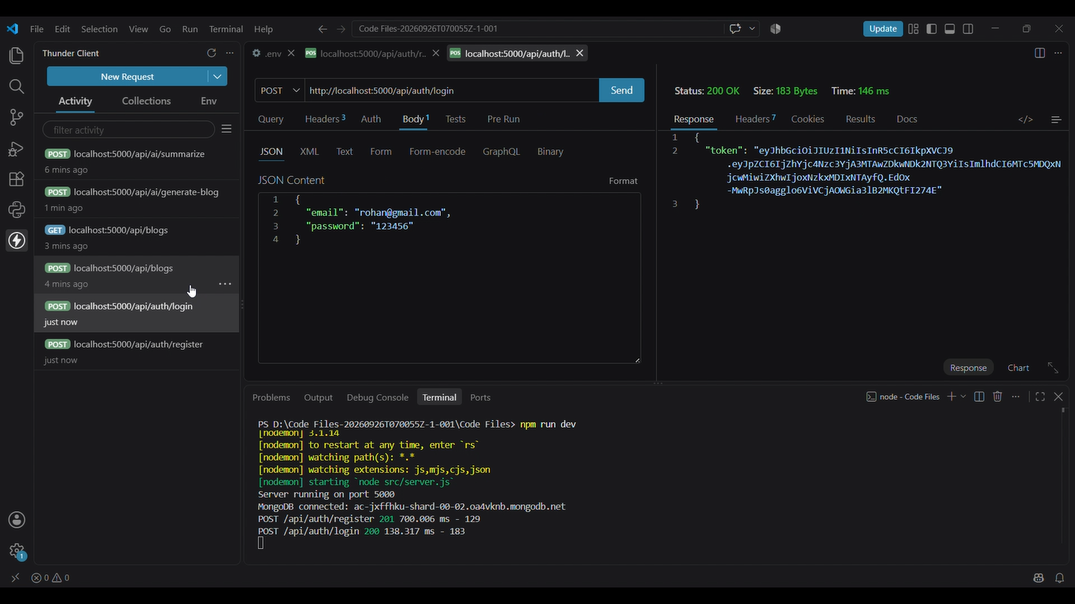

Create Blogs :
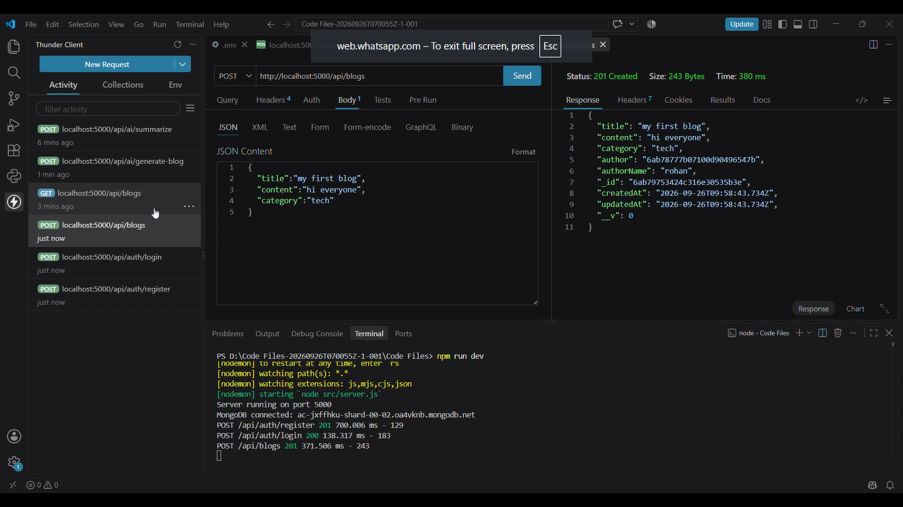

Fetch Blogs :

Generate AI blogs :
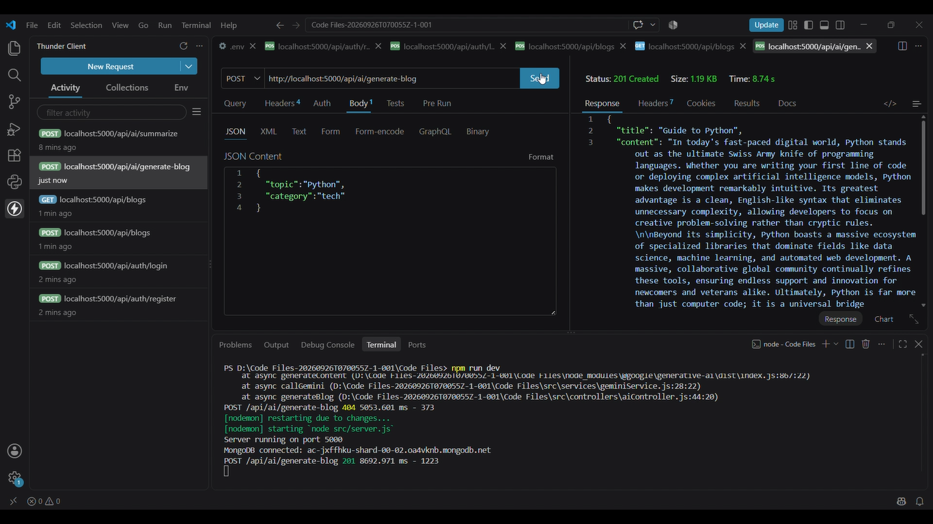
Summarize Blogs :
